When I was a child, we have a black and white TV with 2 channels to choose from.

There was not much to watch, mostly news (it was lots of lies), some politics (all lie) and sports (this was real).

My parents loved to watch Olympic Games and cheer for Russian figure skater. Team USSR was very strong when.

When I got homework related to data visualization for Olympic Games, I wanted to see how did team Russia (not USSR anymore) did and compare It with strongest teams that year. I created 4 charts for you to see.

I also have lots of memories with Sochi where I used to go a lot, beautiful city on Black sea. But I didn’t include it to my site, I will just show a couple of pictures here.

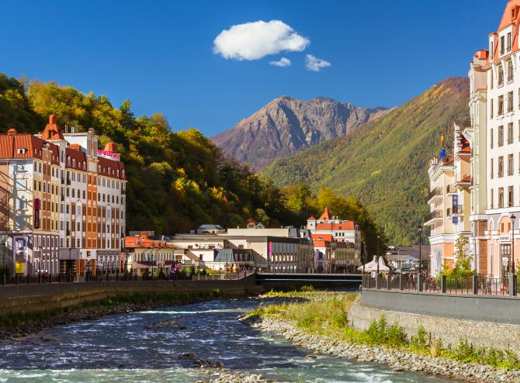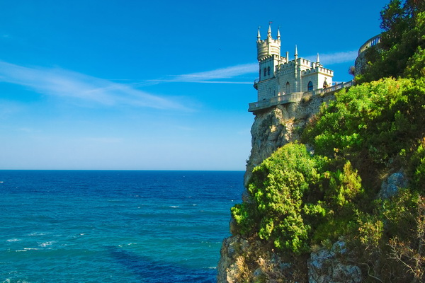

This is Ice Arena

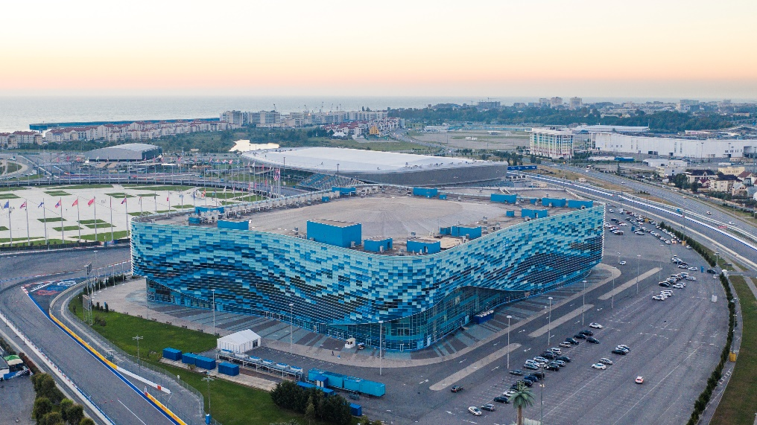

This is my sites wireframe

­